**Thawan Duchanee (1939-)**

Thawan Duchanee, a National Artist from the year 2001, is one of the best-known artists in Thailand, both for people in the art scene and the general public. He first gained recognition in 1967 with the exhibition of his early series of paintings, in which he represented spiritualized power by drawing from a combination of various forms of idealised Thai beliefs and images from his own imagination. The work is beautiful and complex but is easily understood by audiences at an international level. Tawan’s most famous artworks often consist of human and animal forms, which are inspired by Buddhism, Eastern philosophy, and Thai literature. With his excellent knowledge of anatomy, Tawan has designed various beautiful figures that are full of imagination and emotion. Some are depicted with strong muscles in variety of aggressive actions, while some are created to represent feelings of calm and peacefulness. Violent expression is often mixed with graceful and complicated patterns created in the volumes of light and shadow. Most of Tawan’s enormous artworks use black and white tones with perhaps a few colors inserted in them. The movements of characters cover the entire canvas. Some his artworks are quickly and skillfully painted, mimicking the brushwork of Chinese painting, while some are elegantly created by small lines of ballpoint pens.

Thawan graduated with a bachelor degree in Fine Arts from the Faculty of Painting, Sculpture and Graphic Arts, Silpakorn University and continued his education at the art institute in Amsterdam, the Netherlands. At present, he retains a lot of influence on the younger generation of artists, his works mostly focusing on an exploration of Eastern spirituality, natural inspirations and imaginings related to his belief in Eastern philosophy. Thawan developed his unique style from the detailed and complicated patterns of Thai traditional art. Under the structure of anatomy, strong contrast of light and shadow, the artwork appears as the mixture of reality and supernatural ideal beauty.

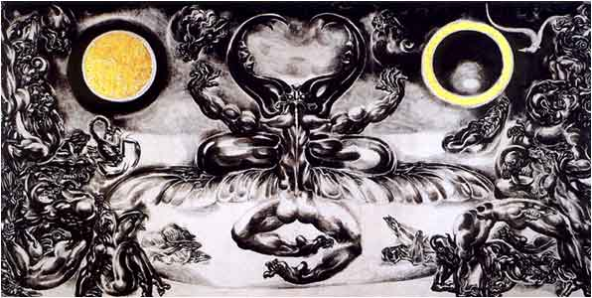

Thawan Duchanee, *Untitled*, oil on canvas, 200 x 401 cm, Collection of the Bank of Thailand, Bangkok.

For almost 50 years, Thawan has created, developed, and exhibited his works in innumerable solo and group exhibitions throughout a number of famous art galleries and museums in worldwide, including Stedelijk Museum in Amsterdam, Santa Barbara Museum of National History in the USA, Stanford Art Museum in California, Pacific Asia Museum, Art Olympia Centrum in Munich, Germany, Schulwarte Waldchulweg, Switzerland, National Museum, Malaysia, Goethe Institute in San Francisco, Museum of Modern Art of Fukuoka and the Japan Foundation. Furthermore, he was awarded the 12th Fukuoka Asian Culture Prize and also received invitation from UNESCO and TIMTOTCA to be their Asian representative in staging his series of artworks titled ‘Art Beyond Borders’ in the International Art Exhibition at United Nations, New York in 2001. As one of the country’s most famous artists, Thawan’s paintings are considered to be among the most expensive in the Thai art market.

**References and Further Reading:**

Hi - Class Magazine. (1995). *16 Thai Contemporary Artists.* Bangkok: Hi - Class Magazine.

Museum of Thai Contemporary Art. (2006). *Drawing of Thawan Duchanee.* Bangkok: Museum of Thai Contemporary Art Limited Company.

Russell, Marcus. (1974). *Thawan Duchanee: Modern Buddhist Artist.* Chiang Mai: Silkworm Books.

Tawatchai Somkong. (January 2004). *Tawan Duchanee*. Bangkok: *Fine Art Magazine*, 50-93.

Vichoke Mukdamanee. (2003). *6 Decades of Thai Contemporary Art*. Bangkok: Silpakorn University Art Centre.